# Raspberry pi

# Format booted raspberry pi SD card

* Download SD Format software and format SD card

# Install Rasbian OS to raspberry pi

* Download latest rasbian os (current - NOOBS)
* Extract zip file
* Copy to SD card
* Boot SD in raspberry pi

# Connect raspberry pi to laptop screen

* Internet and sharing center
* Change adapter option
* Wifi – right click – properties
* Sharing
* Check – allow other network users to connect this pc
* Ok
* Now the wifi status changes to shared
* In pc
* Open cmd
* Ipconfig
* Note down ipv4 address of LAN WIFI: (192.168.1.23)
* Download ipscan software
* <https://www.advanced-ip-scanner.com/>
* 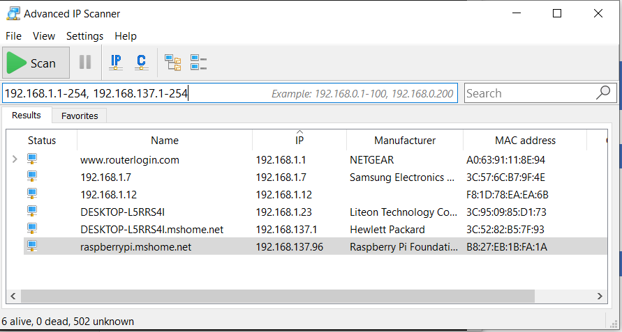
* Download putty
* <https://www.chiark.greenend.org.uk/~sgtatham/putty/latest.html>
* Open putty
* Paste raspberry pi ip into puttys hhost name field
* If connection refuse error occur goto
* Username:pi
* Password: raspberry

# Connect raspberry pi to VNC

* Raspberry pi >
* Preference >
* Raspberry pi configuration >
* Interface >
* Enable VNC
* Not working …

## 2nd method

* Connect putty to raspberry pi
* sudo apt-get update
* sudo apt-get install tightvncserver
* set the password for vnc server
* tightvncserver
* enter password
* New 'X' desktop is raspberrypi:1
* vncserver :1 -geometry 1024x768
* A VNC server is already running as :1
* That’s all for raspberry pi
* Open vnc in Computer
* Type ip - 192.168.43.116:1 and password

# Putty connection refuse error

<https://www.avoiderrors.com/connection-refused-raspberry-pi-4/>

# Basic commands

## Shutdown

* sudo shutdown -h now

# 4*4 LED display

## Opencv installation in raspberry pi

[LearnOpencv](https://www.learnopencv.com/install-opencv-4-on-raspberry-pi/)

## Object detection raspberry pi lite

[Youtube video](https://www.youtube.com/watch?v=aimSGOAUI8Y)

## Run python when reboot

[Youtube](https://www.youtube.com/watch?v=BJbKvEWZXak)

[Website](https://www.pyimagesearch.com/2016/05/16/running-a-python-opencv-script-on-reboot/)

* systemctl status myProg
* sudo systemctl start myProg